Guide to Rose Diseases
http://gulfdistrictrose.org/assets/a-guide-to-rose-deseases-and-their-management.pdf

This information is meant as a general guide only, consult a rosarian when in doubt or your area extension agent. Always consult chemical application guide and practice good personal protection habits - wear googles and gloves!
If you suspect a disease, disinfect all equipment between plants and uses!

GARDEN BAD GUYS - THE BIG THREE ROSE DISEASES - Taken from: http://www.marinrose.org/mildewbsrust.html
by Nanette Londeree, Consulting Rosarian

What happens when you combine our lovely spring weather - cool nights and warm days, and a rain that lasts for a day or two? Well, besides the proverbial May flowers, it is the appearance of the BIG THREE fungal diseases of roses – powdery mildew, blackspot and rust. And just in time for the big show! The bad news is that as long as we have rain, the opportunity for blackspot and rust exist. The good news is that as soon as our rainy season ends, they generally disappear, or at least can be controlled.

Blackspot and rust both require free water to reproduce – thus rainy weather, or overhead watering that wets leaves and doesn’t have enough time to dry produce optimum conditions for these diseases. Blackspot needs about 7 hours with temperatures of 65 – 75 degrees; rust prefers temperatures of 65–70 degrees with 2 - 3 hours of free water. Powdery mildew does not need free water to reproduce – in fact, free water can actually inhibit its growth. Its favored growing conditions are daytime temperatures in the low 70s with a relative humidity of 40-70 %, and nighttime temperatures near 60 degrees.

Powdery mildew is one of the most common of the three diseases. It is caused by the fungus Sphaerotheca pannos and produces a white, talcum-powder-like growth on the top and bottom of the leaves and stems, also on buds or flowers. New leaves may become curled or twisted and the shoots may look badly deformed. The fungus may also infect older leaves. The upper surface of the leaves often appears normal despite extensive fungus growth on the underside of the leaf. When the disease is severe, plants become stunted and leaves curl and drop.

Powdery Mildew
It is caused by the fungus Sphaerotheca pannos and produces a white, talcum-powder-like growth on the top and bottom of the leaves and stems, also on buds or flowers. New leaves may become curled or twisted and the shoots may look badly deformed. The fungus may also infect older leaves. The upper surface of the leaves often appears normal despite extensive fungus growth on the underside of the leaf. When the disease is severe, plants become stunted and leaves curl and drop.

Black Spot
Diplocarpon rosae is the fungus that causes blackspot. It produces characteristic round black spots with fringed or feathery margins on the upper surface of leaves or stems. On some varieties of roses, there may be yellowing around the spots that may extend to the entire leaf. The spots are generally seen first on leaves close to the ground. Infected leaves will drop off, and the plant may be almost completely defoliated. Such plants are badly weakened and may die over the winter.

Rust
Rust is fairly easy to identify with its orange, powdery pustules on the undersides of leaves and other plant parts. Early in the season these may appear as yellow to light orange, with the color deepening to dark orange to red brown in the summer. There are nine different species of the rust fungus Phragmidium found on roses.

Cercospora Leaf Spot - Reference: http://www.rose.org/rose-care-articles/cercospora-leafspot-in-roses/
Symptoms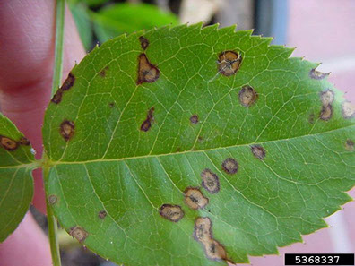
Cercospora leaf spot is characterized by the appearance of numerous tiny maroon to purple oval spots scattered randomly across the leaf surface Later, the center of the spot turns tan to almost gray in color while the margin of the spot remains maroon to dark purple. Heavily spotted leaves will turn yellow and prematurely shed. Because Cercospora-damaged roses typically lose most of their leaves, this disease can easily be confused with blackspot.

Disease Cycle
Very little specific information is available concerning the development of Cercospora leaf spot on roses. However, the same warm wet weather patterns, which favor the spread and development of blackspot, will also start outbreaks of this disease. Beginning in early spring, spores of the causal fungus Cercospora are spread by air currents to the newly expanded leaves. Free water on leaf surfaces triggers spore germination and infection of the leaves. Frequent rain showers or possibly overhead watering favors continued disease spread until the first hard frost in the fall. Control Currently, selected shrub and ground cover roses appear to be the main targets of Cercospora leaf spot. The reaction of these roses to Cercospora leaf spot is summarized in the following table.

Reaction of Selected Shrub and Ground Cover Roses to Cercospora Leaf Spot

Susceptible: Petite Pink Scotch, The Fairy, Fushia Meidiland, Carefree Delight, White Flower Carpet, Happy Trails, and Flower Carpet
Highly Resistant to Immune: Jeepers Creeper, Ralph’s Creeper, Royal Bonica, Nearly Wild, Betty Prior, Sevillana, Magic Carpet, Easy Livin’, Cherry Meidiland, Pearl Meidiland, Rosa mutabulis, Rosa wichuraiana, First Light, Bonica, Carefree Wonder, Sea Foam, Pink Grootendorst, Nozomi, Red Cascade, Mystic Meidiland, Hansa, Double Delight
Source : Hagan, A. K., R. Akridge, and J. Olive. 1999. A rose is not just a rose. Al. Exp. Sta. Auburn University Highlights of Agriculture 46(3):18-20

Note: Many of the roses resistant to Cercospora leaf spot are susceptible to blackspot. Although no fungicides have been screened for the control of Cercospora leaf spot on rose, a number have activity against other Cercospora diseases on other woody ornamentals. Fungicides, such as Daconil, Immunox, Zyban, and Cleary’s 3336, which are recommended as weekly treatments for blackspot control, should also provide good protection from Cercospora leaf spot when applied on the same schedule. Follow the label on each container for recommended application rates and treatment intervals for the above fungicides.

Here are some general controls for all three of these diseases:

Buy and plant disease-free plants
Choose resistant varieties
Avoid wounding plants during transplanting
Plant roses in areas with good soil drainage and ventilation
Avoid shady spots and dense plantings
Remove and destroy infected leaves and canes during the season, rake up and discard infected, fallen, dead leaves
Avoid overhead watering – water on the leave surface increases the chances for rust and blackspot
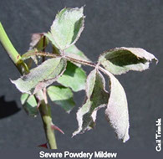
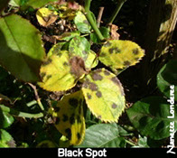
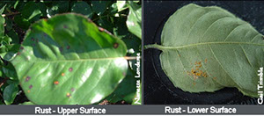

Virus and Virus Like Disease:

Rose Rosette Disease - by Ken Kelley

The worst news a grower of roses could hear is that their roses are infected by the Rose Rosette Disease. This disease is causing devastation across much of the United States. It has been found in one garden in Monroe a few years back and recently in Bossier City, Louisiana. Every person that grows or just enjoys roses should be watchful of evidence of the disease. The virus is spread by the Eriphyid Mite and once infected the plant cannot be rehabilitated and must be removed at once (including all root system). None of this plant should be composted but should be bagged and disposed of. Following any work on plant(s) infected with the Rose Rosette Disease, you should thoroughly clean and disinfect all tools prior to any work on non- infected plants.

Symptoms of Rose Rosette Disease:
• Witches Broom
• Excessive thorn production on roses with thorns
• Excessive growth shoots
• Excessive canes
• Leaf proliferation and malformation
• Red pigmentation or discoloration
• Eventually plant death

It is important to be able to recognize the difference in Rose Rosette Disease and normal new growth on plants that will exhibit some of the same red pigmentation. If in doubt contact a Rosarian for guidance. Below is an informative video on Rose Rosette Disease with Dr. Greg Church from Texas A&M University.

Greg Church – Rose Rosette Disease
https://www.youtube.com/watch?v=ksNlwfdM9ZQ&feature=emb_logo

Rose mosaic – 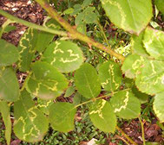
This disease is caused by a complex or viruses and is characterized by yellow patterns on the leaves. The patterns vary considerably, ranging between all-over fine blotches to patterns of lines in waves. The patterns may appear on a few or many leaves. Plants are infected by this virus at propagation using infected plant material. See: McMaugh, J. What garden pest or disease is that?, New Holland Publishing, Sydney, 2001
(at right Rose mosaic virus on R. "Queen Elizabeth")

Rose wilt –
Rose wilt is a complex of viruses and is referred to as dieback in some areas. The disease can be spread by vectors such as aphids. Symptoms are variable and range from stunted growth to curled young leaves. The soft tissue symptoms are more evident in spring and new leaves will reflex towards their own petioles. The affected leaves are brittle and easily fall from the plant. Fully formed leaves will 'wilt' as if the plant were water stressed.

Nutrient Problems
Many issues can be traced back to a nutrient problem. Should you suspect a nutrient issue the first step is to request a soil test! Finding the actual nutrient concentration in your soil can take the guess work out of many situations!

Nitrogen Deficiency

Nitrogen contributes primarily to green growth and is used most heavily when your plants are growing rapidly. The leaves of a nitrogen deficient rose show an over-all yellow or light green color. The older leaves are more affected than the newer growth because nitrogen is mobile within the plant and will move from the older foliage to newer leaves when in short supply. This older foliage may turn clear yellow and ultimately fall off. Slower growth, stunted plants and reduced stem length and diameter are also symptomatic of nitrogen deficiency. Flowers of the darker colored cultivars may appear several shades lighter than normal and the buds of any variety may fail to open.

Iron Deficiency

Iron deficiency results in interveinal chlorosis of the younger foliage (yellow foliage, green veins). If the condition worsens the newly formed leaves may remain small and can become completely pale yellow to white. Iron deficiencies can be induced by high levels of manganese, zinc, or phosphorus. Iron deficiency symptoms with adequate iron present can also be caused by excessive salts, high pH, over watering, poor drainage and temperature extremes. In order to be identify and correct iron deficiency symptoms, these other environmental and cultural problems must be addressed.
Manganese deficiency can cause pale mottled leaves and interveinal chlorosis of young foliage.

Phosphorus Deficiency

Phosphorus is essential for good root growth and flower production. The first symptom of phosphorus deficiency is an overall stunting of the leaves and shoot growth. Later, the older leaves may lose their luster, becoming dull green, and drop off. Root development is reduced, which results in poor flower production and slow-to-open buds on weak stems. A slight purpling of the underside of the midrib can develop on some cultivars.

Potassium Deficiency

Potassium encourages root growth and vigor increasing your plants resistance to disease. Deficiency results in slow growth, shorter than normal weak flower stems and small short deformed flower buds. Tip and marginal leaf burn beginning with the older leaves. Potassium deficiency may contribute to the production of "blind shoots" (new stems with no flower).

Calcium Deficiency

Calcium deficiency causes abnormal root growth causing the tips to shorten, get brittle and eventually die. Young leaves are distorted, older foliage become dull green and may curl down at the margins. Calcium deficiency can also contribute to weak stems and in the cut flower industry is associated with a condition known as black tip on some red rose varieties. There is a relationship between calcium and boron for normal growth. If calcium levels are high the relative boron levels must also be high for boron deficiency symptoms not to occur.

Magnesium Deficiency

Magnesium is essential for photosynthesis. Deficiency can cause stunting and yellowing between the veins on the foliage (AKA interveinal chlorosis). These symptoms show up on the older foliage first because magnesium, like nitrogen is mobile within the plant. This yellowing can eventually cause purplish or brown dead spots that can eventually cover the entire leaf.

Sulfur Deficiency

Sulfur deficiency causes young leaves to develop light green to yellowish in color. Plants may be spindly and smaller than normal.

Boron Deficiency

Boron deficiency can cause small, thickened, curled, scorched leaves and death to the terminal bud. Death of the terminal bud causes lateral buds to develop contributing to witches broom effect. Boron deficiency can cause "bullheads" (flowers with shortened petals, that are abnormally thick and have the margins roll in).

Chlorine Deficiency

Chlorine deficiency can cause malformed wilted foliage, followed by chlorosis. It's believed that an adequate supply of chlorine increases disease resistance.

Copper Deficiency

Copper deficiency symptoms include distorted young leaves with yellow tips. Ultimately the growing point dies, and short, stunted, lateral shoots develop.

Molybdenum Deficiency

Molybdenum deficiency can cause stunting and lack of vigor. It can also cause malformed leaves with marginal scorching and cupping. Molybdenum is used in very small amounts and can be toxic if over applied. Molybdenum deficiencies can be corrected with only a few ounces applied per acre.

Zinc Deficiency

Zinc deficiency symptoms are similar to those caused by copper deficiency. However, zinc deficiency can also the lateral shoots that develop after the terminal bud dies to stunt causing "little leaf" symptoms.

Bacterial Diseases:

Crown gall rot
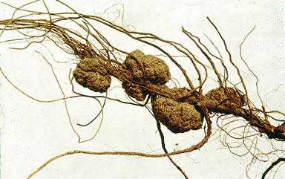
Agrobacterium rhizogenes – This disease is characterized by large lumps at the base of the plant stem or on roots. Galls may appear higher on stems as the disease progresses. Galls are soft compared to surrounding plant tissues. The pathogenic bacteria enter the plant via a wound. If the disease affects the plant whilst it is young the plant may be affected to the degree where it will not produce blooms. All affected plants wilt readily and grow poorly.

If you suspect Agrobacterium rhizogenes you should immediately take action by destroying all plant and soil materials, and sterilize all tools that come in contact with this plant and soil material.

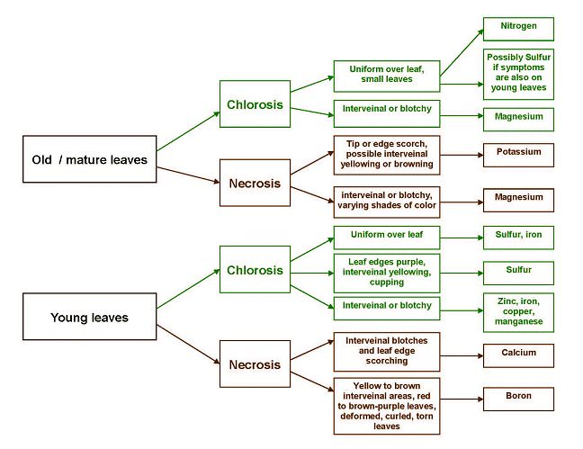
Bacterial Diseases:

Crown gall rot
Agrobacterium rhizogenes – This disease is characterized by large lumps at the base of the plant stem or on roots. Galls may appear higher on stems as the disease progresses. Galls are soft compared to surrounding plant tissues. The pathogenic bacteria enter the plant via a wound. If the disease affects the plant whilst it is young the plant may be affected to the degree where it will not produce blooms. All affected plants wilt readily and grow poorly.

If you suspect Agrobacterium rhizogenes you should immediately take action by destroying all plant and soil materials, and sterilize all tools that come in contact with this plant and soil material.

Fungal Diseases:

Black Spot 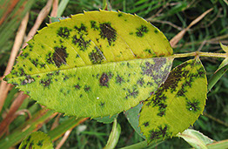
Diplocarpon rosae syn. Marssonina rosae – Marssonina rosae causes black spots on leaves. The spots, which may be as much as 12mm across, are generally circular and have an irregular edge often with a yellow halo. Leaves frequently turn yellow and fall early. Sometimes new leaves are produced, and these may also become affected. Continual defoliation will cause weakness, dieback or death of the plant. Some very susceptible species may have stems affected with a considerable reduction in plant vigour.

Powdery Mildew (Podosphaera pannosa) 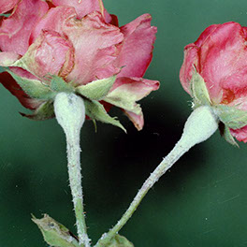
Powdery Mildew Podosphaera pannosa – P. pannosa produces a very fine, powdery coating on the surface of buds and leaves. Significant cases have stems and particularly thorns, infected. Attacks on young leaves and buds will cause deformity with retardation of growth. Infected buds will fail to open. The disease is likely in hot, humid weather, with fungal spores overwintering on the stems and fallen leaves.
At right Powdery Mildew

Downy mildew
Peronospora sparsa – Peronospora causes purple-red to dark-brown spots on the leaves with irregular margins, however, often angular. Stems, petioles and flower stalks can split and spotted with purple marks. Buds, sepals, petals and calyces can be affected and will present purple spots. New growth affected will be deformed. The disease is spread by wind.

Rose rust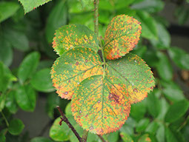
Rust Phragmidium mucronatum – Rose rust appears as yellow patches on the surface of leaves, with orange pustules of spores underneath the leaf. The fungus is spread by wind. Affected leaves fall prior to healthy ones and plants may be defoliated in serious infections.

Anthracnose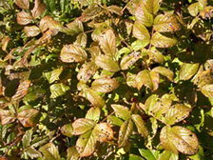
Sphaceloma rosarum – Spots caused by this fungus originate from a point where leaves are water soaked, usually unnoticeable at first, until they turn black with a very distinct defined edge. As the spots enlarge the centre becomes gray and may fall out resulting in a shot-hole appearance. Defoliation may occur but is often not serious. See: Rose-growing for Pleasure, Lothian Publishing, Melbourne, 1985, ISBN 0-85091-181-8 pp. 28

At left Anthracnose on Rosa rugosa

Grey mould
Botrytis cinerea – On roses grey mould is primarily a disease of the flowers and buds, leaves are infrequently attacked. Infected buds rot on the stem and infection may progress down the stem. On petals botrytis cinerea produces pink rings.

Sooty moulds
Alternaria spp. – Sooty mould appears as black, dry powder on leaves similar to chimney soot. Many sooty moulds grow on the honeydew (frass) produced by sap-sucking insect such as aphids and soft scales. Alternaria does no direct damage to plants but surface cover of leaves will reduce the plants capacity to photosynthesise and may create an unsatisfactory plant appearance. See: Macoboy, S., Macoboys' Roses, Mallon, Melbourne, 1999, ISBN 1-875696-00-8

Canker
Leptosphaeria coniothyrium and Cryptosporella umbrina – Cankers present as small yellowish or reddish spots on bark slowly increasing in size. Leptosphaeria coniothyrium turns brown, increases in size, and may eventually girdle the stem. The tissue within the infection begins to dry out and shrink, presenting a shriveled appearance. If the disease infects only part of the stem, growth above the canker will continue. If it girdles the stem, however, growth will cease and the stem will die. See: http://www.rosemagazine.com/articles04/rose_stem_canker/
Insects that affect roses are often considered pests.

Aphids: (Greenfly) (Order Hemiptera Family Aphididae) Macrosiphum rosae – Likely to be found on new shoots and buds, aphids are soft bodied insects 1-2mm long. Often green but occasionally light-brown, and sometimes with wings, they may cover (in a colony) the complete growing tip of the plant. Aphids are most active in spring and summer and multiply at a prodigious rate feeding on the sap of the plant by piercing the plant cells via a proboscis. In large quantities they may seriously retard the growth of the plant and ruin buds. They are particularly damaging to the new shoots with subsequent damage to the emerging leaves which become malformed with much the same appearance as leaf-curl in peaches.

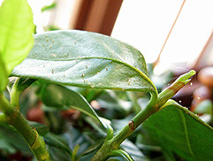
Two-spotted mite (Spider-mites or Red spider mite) (Order Acari: Family Tetranychidae) Tetranychus urticae – Previously known as red-spider mite these arachnids prefer the underside of leaves and are difficult to see with an unaided eye. Evidence of their presence is silvering of leaves where the mites have destroyed individual leaf cells. Fine webbing and eggs on the undersides of leaves is further evidence of the presence of Tetranychus urticae. (At right two-spotted mite infection on gardenia)

Thrips (Order Thysanoptera) –
Thrips are slim-winged insects 1mm in length, resembling fine slivers of wood or rice. Preferring light-coloured blooms and often appearing in plague numbers, flowers are often left looking scarred, warped, and lustreless.
​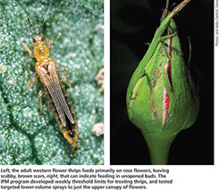 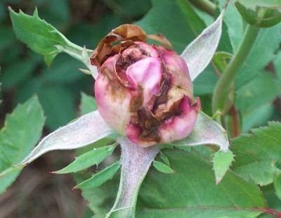

Chilli Thrips- Reference: http://www.rose.org/chilli-thrips-dont-let-em-bug-you/
Scirtothrips dorsalis Hood, is an extremely successful invasive species of pest-thrips which has expanded rapidly from Asia over the last twenty years, and is gradually achieving a global distribution.
Chilli thrips appear along the Gulf Coast in May and take up residence until September. The first plant to be affected in this area is the Indian Hawthorne. From there they move from plant group to plant group feeding on any plant species with new growth. Roses are a favorite host because roses have new growth from spring until winter. Chilli thrips were worse last year than ever before, and it is believed that the reason is due to extreme heat in the summer followed by an almost non-existent winter. Chilli thrips are heat-loving bugs.

Unlike Western Flower Thrips that cause unsightly browning of rose petals, chilli thrips feed on leaves and stems and have the ability to decimate a plant. They have rasping, cutting mouthparts that work like little saws, splitting open green plant tissue so that they can suck the juice out of the leaves. Their favorite feeding sites are the tender maroon-colored new growths and where leaflets attach to the stem. In these tight locations, they feed until there is no more juice in the plant tissue and then move on to another spot on the plant. As the leaf continues to develop, scars form at the feeding site and depending on the level of feeding leaves may be distorted or not look like a leaf at all.

Copies of the Chilli Thrips National Plant Alert as well as photographs of chilli thrips damage taken of roses in our area are included on our website, www.houstonrose.org. Correct identification of the pest is critical. Once the presence of chilli thrips is confirmed, the following steps will help you get the problem under control:

- Cut off all parts of the plant that have evidence of damage.
- Bag the trimmings, tightly tie up the bags and send them to the landfill. Do not compost the infected plant parts.
- Begin a spray rotation with a product proven to control chilli thrips.
- Rotate the selection of chemical treatments in order to avoid the pest becoming resistant to the treatment. It is advisable to continue treatment applications for at least 6 weeks.
- Watch the plants for repeat symptoms of pest feeding. As symptoms reoccur – repeat the process.

Rose Slugs (Rose Sawflies)- Sawflies are non-stinging wasps (Hymenoptera) in the suborder Symphyta, not flies (Diptera). They lay eggs in plant leaves or stems with a saw-like ovipositor. There are three species that commonly cause damage to wild or cultivated roses:[5] The Bristly Roseslug (Cladius difformis) is found in Europe, Siberia, and many areas of North America. The larvae is pale green, up to 16 millimetres (0.6 in) long, and covered with hairlike bristles all over its body. It looks like a caterpillar but that term strictly speaking only applies to the larvae of moths and butterflies. It skeletonizes the underside of leaves, with several generations per year. The European Roseslug (Endelomyia aethiops) is found in North America as well as Europe. The larvae is more slug-like (but not slimy), up to 13 millimetres (0.5 in), and skeletonizes the upper surface of leaves with only one generation per year.[5] The Curled Roseslug (Allantus cinctus) larvae is pastel green on the back, marked on the thorax and abdomen with white dots, and up to 19 millimetres (0.7 in) long. It frequently coils up like a snake. After skeletonizing entire leaves except the main veins, it pupates in the pith of canes, with up to two generations per year in North America.

Caterpillars (Order Lepidoptera) See also List of Lepidoptera that feed on roses – The tortryx (tortrix) moth Lozotaenia forsterana is a prominent pest of roses, although not the sole pest. The caterpillars are green, up to 15mm long, and can be found boring into buds or within curled leaves. When disturbed the caterpillars move swiftly, dropping to the ground on a fine thread. Damage is chewn leaves and flowers and buds with "shot holes".
Curculio beetles (Family Curculionidae)

Japanese beetles (Popillia japonica) - This species, introduced to North America in 1912, is now an endemic pest in the eastern United States. Adult beetles emerge from the ground in early summer and join into swarms for four to six weeks, devouring blooms and skeletonizing foliage on roses and many other garden plants. Japanese beetles can be partially controlled, albeit slowly, by spreading milky spore bacillus on the lawn areas where the larvae live. The popular pheromone-baited traps may do more harm than good by attracting beetles from a wide area.

Scale insects
Cottony cushion scale (Order Hemiptera : Family Coccoidea) Icerya purchasi – This scale infests twigs and branches. The mature female is oval in shape, reddish-brown with black hairs, 5 mm long. When mature the insect remains stationary and produces an egg sac in grooves, by extrusion, in the body which encases hundreds of red eggs. The insect causes little damage but produces copious honeydew (frass) that can cause damaging sooty mould.

California red scale (Order Hemiptera : Family Coccoidea) Aonidiella aurantii – A hard scale, orange to orange-pink, the female covering being less than 1.5mm across. Often in plague numbers this scale infests upper surfaces of foliage causing yellowing, leaf fall, and twig and branch dieback. Serious infestations can cause plant death.

Rose scale (Order Hemiptera : Family Coccoidea) Aulacaspis rosae – Mainly found on the stems and branches of the plant, lack of control will allow the pest to spread to flower stalks and petioles. At this point the plant would be stunted, spindly and with a white, flaky crust of scales on the bark. Female Aulacaspis rosae may live for 1 year and may lay 80 eggs each with several overlapping generations living within milliimetres of the original parent.

