Basic Maintenance:

Add Mulch:
Other than making sure you have the right roses in the right spots, mulching is the best thing you can do to ensure healthy roses.

Mulch makes growing roses easier for a couple of reasons. It helps the soil stay cool and moist longer during hot, dry weather, so you have to water less often. And a layer of mulch over the soil effectively stops many common weeds from growing.

Plus, mulches made from organic matter (such as bark, grass clippings, rotted manure, straw, or shredded leaves) break down and improve the quality of your soil.

It's easiest if you spread mulch after you plant your roses. Most types of mulch work best if they're 1 to 3 inches deep.

Here's a hint: Don't mound mulch right up against the base of your roses. Leave a 1- to 2-inch-wide gap between the mulch and your rose stems.

Water Wisely:
Most roses do best if they get about an inch of water each week during the growing season, depending on your soil type. Gardeners with sandy soil often find their roses need a little more water than those gardeners who deal with clay soil.

You can help keep diseases from attacking your roses (and save money on your water bills) by watering with a soaker hose. Soaker hoses slowly seep water directly at ground level -- and if you cover them with mulch, they lose very little moisture to evaporation.

Sprinklers can be problematic because they send water into the air. Wet rose foliage, especially in the evening or nighttime hours, can encourage fungal diseases. It can also be wasteful to water with sprinklers: On hot, sunny day, some of the water will evaporate before it reaches the ground.

Pruning Roses: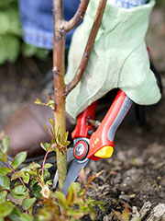
In most areas, early spring is the time to prune your roses. Many experts recommend pruning your roses about the time forsythia blooms in your area.

Note: Exceptions to this include roses that bloom just once a year in early summer. Prune them right after they finish blooming.

Hybrid Tea, Grandiflora, and Floribunda Roses:

Since we typically only prune our roses once a year, it can be tough remembering how and when to do it. If you need a refresher, here's our guide.

Cut back your hybrid tea, grandiflora, and floribunda roses to about 18 inches tall in early spring, just before they start to grow. One guide to help you know when to prune is to watch for forsythia to bloom. In the coldest climates, prune these roses back to live growth. It may be as low as 8 inches, depending on how severe the winter was.

Because many of these types of roses are grafted, watch for any shoots that seem to be coming from the roots and not the rose stem. These are usually unwanted suckers from the root system and should be removed at ground level.

Though it may seem like butchering, pruning this way will give you plants that produce lots of lush blooms on sturdy stems.

Climbing Roses
Climbing roses can be a little trickier to figure out. The best time for pruning depends on what kind of climbing rose you have. Prune those that bloom only once a year right after their blooms fade. Reblooming climbers, on the other hand, should be pruned in early spring.

Shrub Roses
Shrub roses may not need pruning at all, but it depends on what type you have. Many modern shrub roses require no pruning except to remove dead or damaged growth. If your shrub roses bloom once a year, lightly prune them back after their flowers fade. Prune back reblooming shrub roses in early spring.

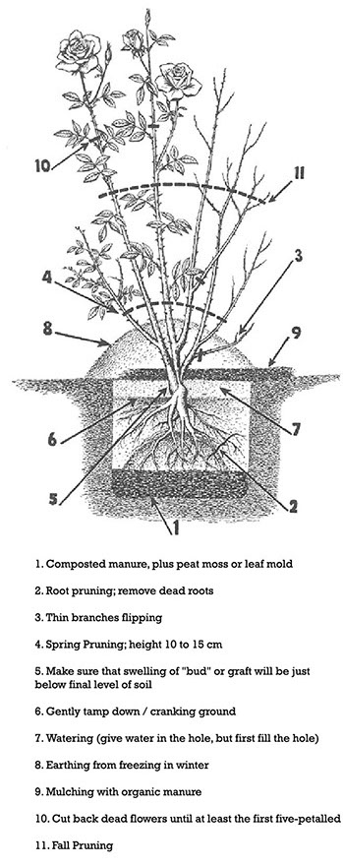
LSU Dan Gill – Time to prune roses
https://www.youtube.com/watch?v=8yUIbgIk8v8&feature=emb_logo

LSU Dan Gill – Knock Out Rose pruning
https://www.youtube.com/watch?v=12wH-iqjv8U&feature=emb_logo

Deadhead Spent Blooms
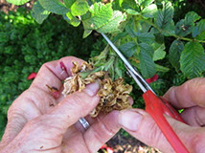
Deadheading, or cutting off flowers after they fade, helps your roses look better and allows the plants to put more energy into producing blooms instead of seeds.

Note: Don't deadhead your roses if you want to enjoy their hips (fruits). Deadheading roses will stop them from producing hips.

Here's a hint: Deadhead your roses with a pair of sharp pruning shears. Clean cuts heal faster and attract less disease than crushed stems.

How to Deadhead Roses
https://www.youtube.com/watch?v=4e41SQEaUAY&feature=emb_logo

LSU Dan Gill – Taking care of roses for Fall and Winter months
https://www.youtube.com/watch?v=dKvv2EqvEBM&feature=emb_logo

LSU Dan Gill – Choosing the Right Sprayer
https://www.youtube.com/watch?v=t1TkidE147I&feature=emb_logo

Spraying Your Roses-

There are many disease resistant roses on the market today but generally most roses will benefit from a regularly scheduled spraying. In this area, roses are prone to fungus, disease and pests. So make sure you keep a constant watch on your plants. Common practice is to begin your spraying routine immediately after spring pruning and continue spraying until your roses go dormant in the fall.

Pests are by far the greatest concern for rose growers early on and it is Aphids and Spider Mites that can wreak havoc with your roses. Aphids go right after new growth and typically appear in mid to late April. You most often will see them covering emerging buds. A water spray will knock them off of the buds but either Orthene or Merit will eradicate the problem for the season. Keep in mind they may return with the warm days and cool nights of fall.

Our other pest gets top billing as the Spider Mite will defoliate a bush if left unattended. It is very difficult to actually see a Spider Mite but if it is hot and you have graying or yellowing of the leaves moving from low on the plant upward chances are you have Spider Mites. If you look at the underside of a leaf you can usually feel the mites; they will appear as tiny dark dots. Smaller roses such as Miniatures and Minifloras are more commonly attacked although all roses are susceptible to the problem. The problem with Mites is that they reproduce in three days; not something you want to overlook unless you are not concerned about foliage.

Spraying the undersides of leaves with a water wand will knock most of the mites off of your rose bush. This is where consistency comes into play as mites have a three day reproduction cycle. In order to bring the Spider Mites under control it is best to spray every two to three days for at least five sprayings. Doing this as suggested should alleviate your Spider Mite problems. We have found that Neem Oil works well but if you have a severe problem you may need to use a miticide like Avid or Merit. Rosemania.com is a very good source to purchase insecticides.

Most of the diseases associated with rose bushes are caused by Fungi. Fungal diseases that you may or may not experience in the spring will most certainly make their presence known come summer and fall. This is why you need to be diligent in your spray program beginning in early spring. Most fungicides call for a spray application at seven-to-fourteen-day intervals. We spray weekly and typically do not notice disease unless it is an isolated incidence at which case we spot spray in addition to our regular spray program.

It is best to spray your roses early in the morning (never spray roses during the middle of the day as this can cause the leaves to burn). Make sure to read the label of ALL the chemicals that you are using, and wear recommended Personal Protective Equipment. Add half of the water you to the sprayer tank that you plan to mix. Then add any powder chemicals (always pre-mix any powder chemicals with a small amount of water and ensure it is well dissolved). Then add remaining fungicide or insecticides and adjuvants. Spreader stickers are great to add to some chemicals but should not be added to others. Once all chemicals have been added, fill the sprayer tank with remaining water. Shake well to make sure that all chemicals are well mixed.

Start spraying your roses by pointing the nozzle in the upward direction and spray the underside first of the leaves first. Then make another pass and spray the top of the leaves. When finished spraying all of the roses and there is some remaining chemicals in the sprayer, make another pass over troublesome plants and / or spray the ground of those plants.

Always make sure that you properly clean any sprayer after each use and flush the line and wand with clean water.

Common Rose Chemical Application Guide

When adding a powder to a sprayer tank it is recommended to mix it with a small amount of water prior to adding to the tank.
**Many insecticides are affected by water pH. Most insecticides are negatively affected if water pH is 9+. Therefore, it may be recommended to add Brandt Idicate 5 as a buffering agent in your area. It also works as a wetting, spreading and penetrating agent.
# Nutritional additives should not be used in combination with oil sprays
## Repeated use of the same miticide is documented to produce resistant strains of mites. Alternate chemicals used.
